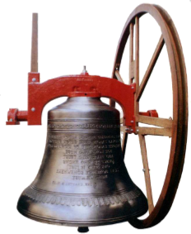

Come and visit us and learn about the intriguing art of Church Bell Ringing!

Tower Open on ………………………………...

From …………………… to ………………......

More Information ……………………………...

**Tower Open Day**

**____________________________________________________________________________________**

Bellringing

