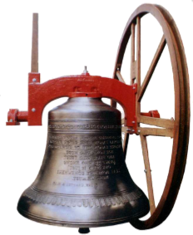

Bellringing

The bells of ……………………………………

Will ring out on ……………………………….

At ………………………………………………

To mark the occasion of ……………………… …………………………………………………. ………………………………………………….

More information ……………………………...

**For a Special Occasion**

