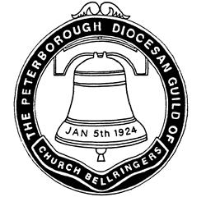 | The Central Council of Church Bell Ringers and  Peterborough Diocesan Guild of Church Bellringers  Safeguarding Information for Ringers | 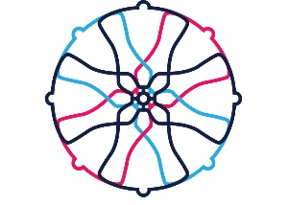
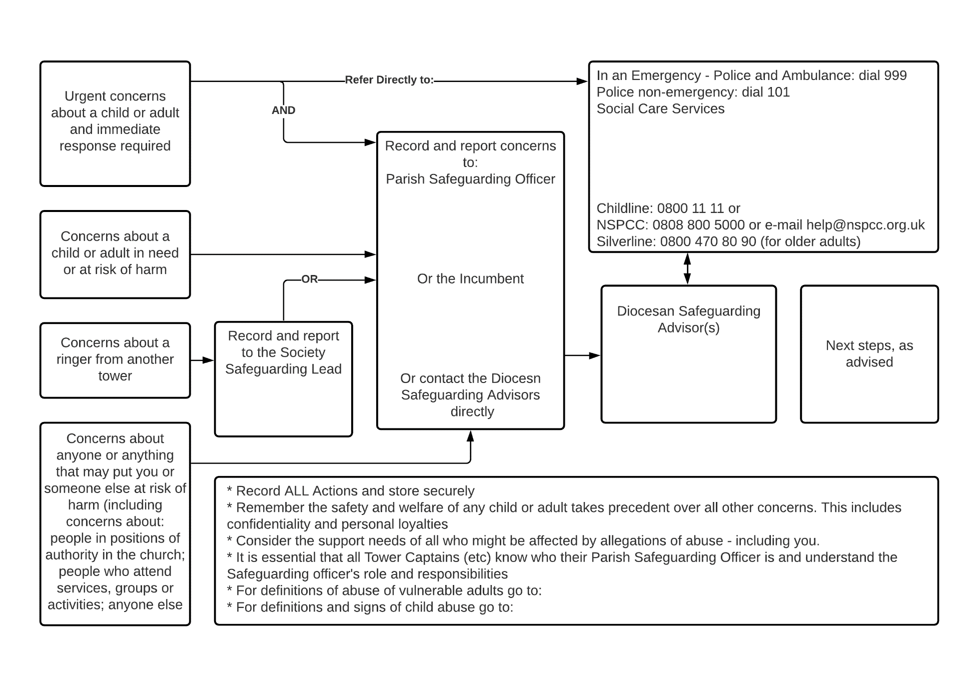
**Name
**Contact
**Name
**Contact
**Name
**Contact
**Name
**Contact
**Organisations
**Contacts

