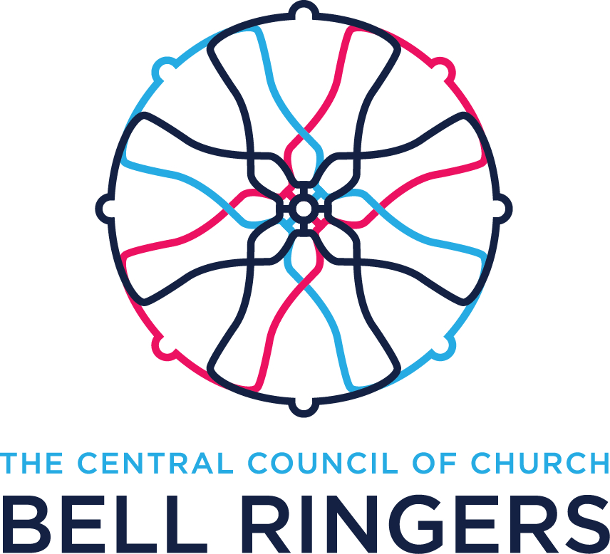
NOMINATION FORM
Annual General Meeting 2023

Registered Charity number 270036

PROPOSER

I, (print name)

Hereby nominate: (print name)

for the position of:

Signed: Date:

SECONDER

I, (print name)

Hereby nominate: (print name)

for the position of:

Signed: Date:

NOMINEE

I, (print name)

hereby accept nomination for the position of:

Signed: Date:

A biographical statement of up to 200 words must also be provided.

This form, and the supporting statement, must be returned, fully complete, by 22nd July 2023* to:

Ernie de Legh-Runciman, Secretary, Central Council of Church Bell Ringers
10 Derwent Drive, Onchan, Isle of Man, British Isles, IM3 2DG
Email: secretary@cccbr.org.uk

Email submissions from the proposer, seconder and nominee are acceptable, on the proviso that the emails originate from a traceable email address.

*Note. The preferred method of delivery is email. If using surface post, please allow at least five days for delivery to the Isle of Man. If possible, please include an email address, so confirmation of receipt can be sent.

