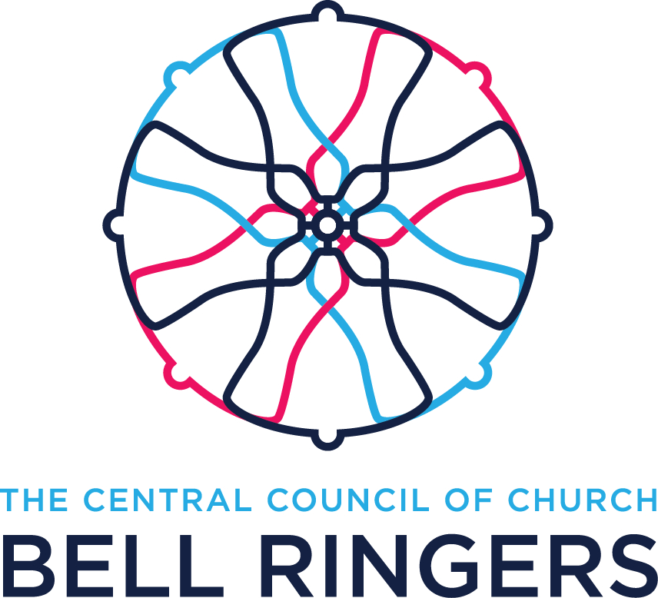 |  | The Central Council of Church Bell Ringers  Registered Charity No: 270036
EXPENSE CLAIM FORM

Committee:………………………………………………………………………………........................
Name: …………………………………………………………………….............................……………
Address:……………………………………………………………………………………………….…..
Telephone: ………………………………… Email:..…………………………………………………..
Expenses claimed
Reason for expenses:.…………………………………………………………………………………..
Date | Detail |  |  |  |  | Amount
 | Travel by private car……..….. miles at …….…p per mile |  |  |  |  | £
 | Travel by public transport. |  | Details……………………………….……………………..  ……………………………………………………………... |  |  | £
 | Other expenses |  | Details……………………………….……………………..  ……………………………………………………………... |  |  | £
Total expenses claimed (where possible please supply original receipts) |  |  |  |  |  | £
Please give details of the bank to which repayment should be made
Bank name:………………….…. |  |  |  | Account name:…………………………………………………..
Sort code: ……………………… |  |  |  | Account number:…………………….………………………….
Signature:………………………………………........................... |  |  |  |  | Date: ……………………
Approved:………………………................................................. |  |  |  |  | Date: ……………………
Notes:
- Please submit this form to the Committee Chairman as soon as possible after the expenses have been incurred
- All expense claims must be with the Treasurer by the end of January following the year to which they relate

