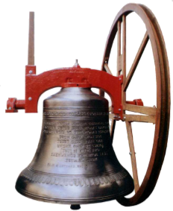

The Bells at this church are rung on:-

SUNDAYS ……………………………………..

PRACTICE ……………………………………

Number of Bells …………… Tenor ………….

Tower Captain/Secretary ……………………...  
…………………………………………………..  
…………………………………………………..

Email …………………………………………...

Telephone ……………………………………...

Bellringing

