Rung at <tower location>

On <when>

A Quarter Peal of <method>

Weight of Tenor <tenor weight> cwts.

The Ringers:-

Conductor <conductor>

Footnote <footnote>

*The Central Council of Church Bell Ringers congratulates*

*………………………………………………………*

*on ringing your first Quarter Peal*

<Ringers>

<Ringers>

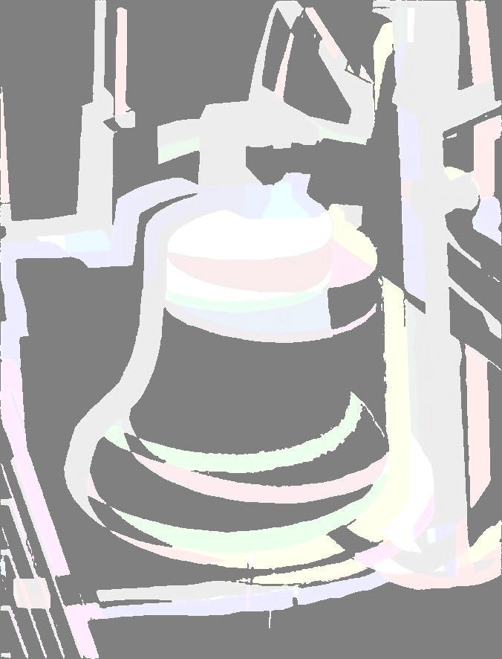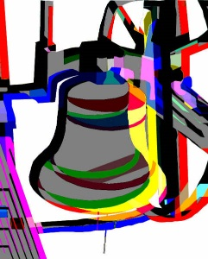

First Quarter Peal