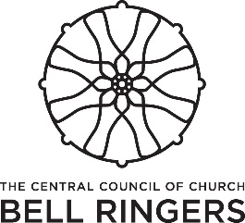

Tower Stewardship Committee

Permission to ring form
Church.........................................................................................................
Full name of child or young person
......................................................................................................................
Date of birth................................................................................................
Address........................................................................................................
......................................................................................................................
Name of parent/ guardian.......................................................................
Contact number:........................................Mobile:...............................
Name of additional contact and number............................................
....................................................................................................................
Medical declaration: Are there any medical conditions (e.g. diabetes, epilepsy) or dietary concerns that we should know about your child? (This will not preclude your child from ringing, but notification now will help in the event of a medical problem). Please give relevant details below or state “none”
…………...........................................................................................................
......................................................................................................................
Permission: I have been shown and understand what is involved in bell ringing and I am aware of the hazards present and the need for physical intervention if necessary. I give my permission for the above child/young person to take part in normal bell ringing activities of the group and understand that separate permission will be sought for outings and activities outside normal times and at other locations.
Unless otherwise advised, I undertake to deliver and collect the child/ young person from these activities.
Signed parent/ guardian........................................... Date..............................
Signed tower leader...................................................................................
Name and contact number.........................................................................

Copies to be retained by tower leader and by parent/guardian

