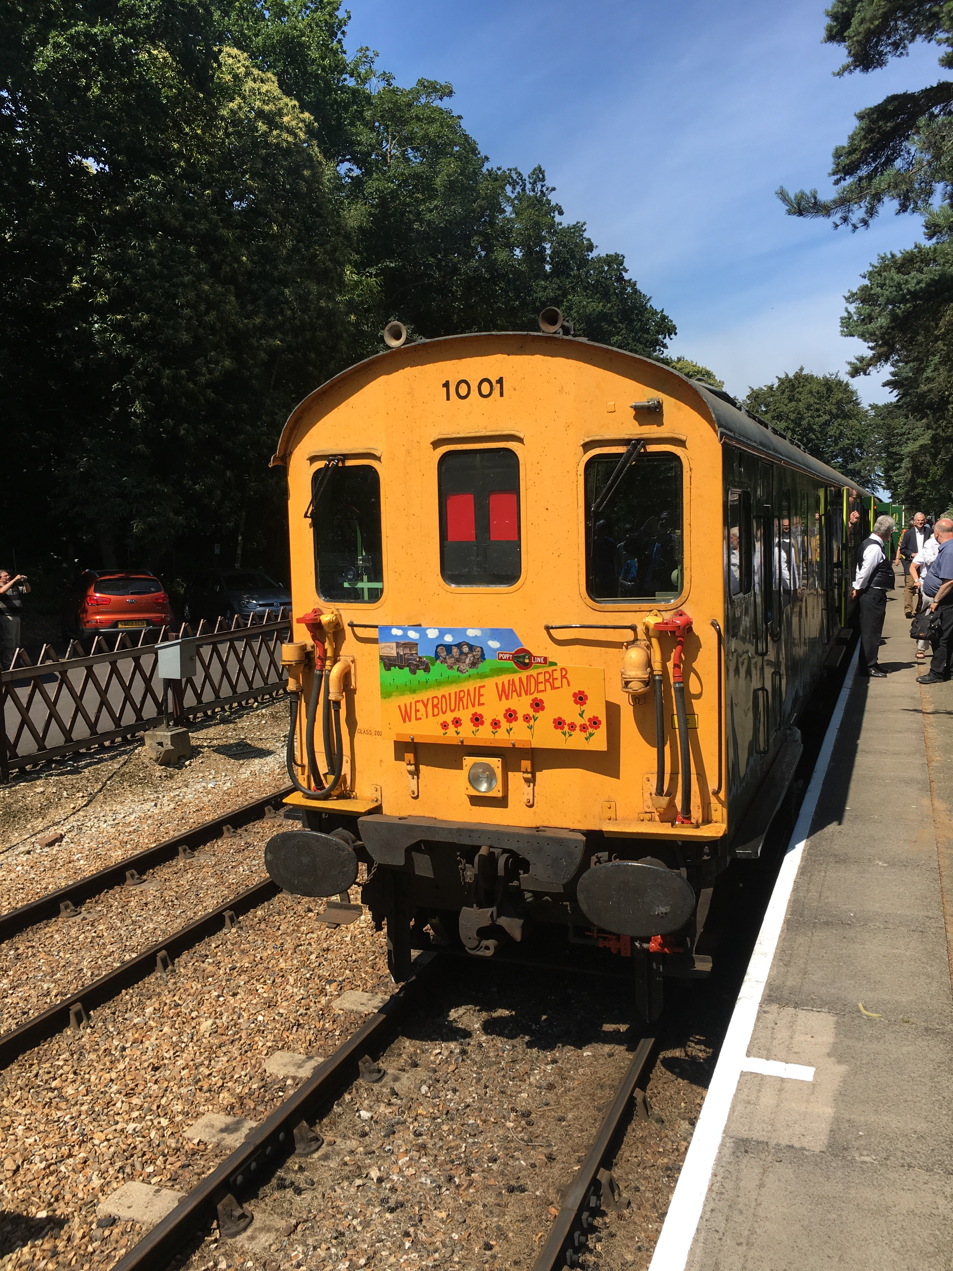

The Strike Back Express

29 July 2017

“What’s the record for the number of bellringers on one train?” One of the learned contributors to this journal may know the answer, but whatever it is, we’re hoping to break it on 29 July! A specially chartered vintage train will travel all the way from Hastings on the East Sussex coast to Bath and back, via Tunbridge Wells, Tonbridge, Bromley South and Clapham Junction, with all profits from ticket sales going to our fledgling charity, SBABC: Strike Back Against Blood Cancer.

First of all, a word about this fund. Many readers will have followed the story of Julie McDonnell’s fundraising efforts over the last year; through a walk along the Pilgrim’s Way to Canterbury Cathedral last June, and through a great deal of sponsored ringing since, particularly in methods named in Julie’s honour. Until very recently the funds have been raised for established charities. Earlier this year, though, the decision was made, after a lot of agonised debate, to set up our own: so the money that bellringers raise, bell ringers in future will have a say in spending. Anyone who has had any experience in recent years of trying to set up a fund and register it with the Charity Commission will no doubt regard this as a “courageous decision” (in the euphemistic words of Sir Humphrey Appleby), and will not be surprised to hear that so far it has taken over three months to open a bank account; and we anticipate the process of registration as a charity may take at least three months more. But we feel very strongly that a small trust like ours will be in a position to make absolutely sure that all the funds raised go towards the charitable objects, rather than being lost, to any extent, in administrative and fund raising costs. And above all we will know, ourselves, that this is the case.

Although I have received some very generous donations and sponsorship amounts from ringers already since SBABC was first mooted, the Strike Back Express is the first major initiative in support of the new fund. It comes about through Louise’s and my other spare time interest, shared with a lot of other ringers, which is railways. In particular, we have been actively involved over the last two years or so in Hastings Diesels Limited, which was formed in the wake of the withdrawal from service, in 1986, of a unique set of trains. Instead of the more normal 9’ 3” or 9’ width coaches, these were made to an 8’ 2 ½” clearance so that they could pass through the narrow tunnels between Hastings and Tonbridge on the Charing Cross line without colliding with trains coming the other way. Introduced from 1957 onwards to replace the narrow “Schools Class” steam locomotives, these slimline diesel-electric multiple units soon attracted admirers amongst train enthusiasts. A group of these got together and ultimately saved from the Chart Leacon furnace fourteen vehicles out of the original twenty-two six car sets. A train comprised largely of these has achieved mainline certification despite the formidable barriers put up by proliferating health and safety requirements and railway red tape, and now runs regular excursions from Hastings to a wide variety of destinations.

Thanks to the generosity of John White and the other devoted volunteers at Hastings Diesels, we have been able to charter the train for the trip to Bath on 29 July. The plan at the time of writing is that the train will not just be full of bell ringers and their friends, but will even be driven by a ringer – Rob Lane of GB Railfreight. When asked what it was like to drive the Hastings DEMU, he described it as “Great. It’s like putting on a comfortable old glove!”

There will be handbells on board, and when we get to Bath we hope to have ringing in towers in the city, thanks to the support and cooperation of local ringers. There will also be time to enjoy the sights and atmosphere of this uniquely beautiful place.

So, how many ringers can you get together in one train? We’d like that number to be a very large one, so if you are interested in joining us, or know someone who might be, do get in touch. There is a booking form that can be downloaded from Julie McDonnell’s website: www.sbabc2017.weebly.com. And of course, non ringing partners, friends and relations are more than welcome!

Alan Pink

