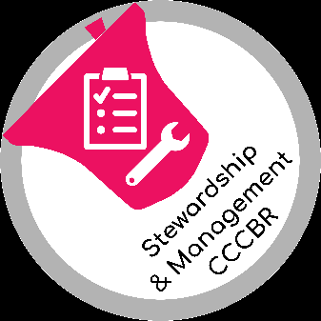
SURVEY OF TOWER AND BELLS

This document aims to enable those undertaking a detailed survey of a tower and its bells, to record their findings. Companion documents offer advice to those requesting advice [1] on bells and their towers, or for those providing such advice [2]; these other documents provide more information about preparation and undertaking surveys.

The level of information and records made will depend on the purpose of the survey and for whom it is being prepared. A detailed survey such as indicated in this document is only likely to be required infrequently, perhaps as part of a Church Quinquennial inspection, in preparation of a Statement of Significance of as part of the planning of a restoration or installation project, and depending on what is already known.

A separate document [3] indicates what more frequent and regular checks of the condition of the bells, their installation and the tower could include.

The form below may be customised, depending on purpose of the survey and for whom the survey is being undertaken; every tower and bell installation is unique. A copy may be printed so that notes may be made during the visit. Inclusion of sketches, photos etc is especially helpful. The information to be recorded is likely to include type, manufacturer, date, key features, condition, specific issues, recommendations etc.

The records and any reports prepared are normally distributed to the people who requested the work to be undertaken, and those responsible for the tower and bells, e.g. the PCC, Church Wardens and Ringers. Reporting is considered in document [2].

Any hazards or observations that may pose risks to people, the tower or bells are best identified very clearly and those responsible alerted as soon as possible. It is also recommended that the urgency for remedial work is indicated, along with any precautions to be taken in the interim.

References:
[1] “How to get Advice on Tower Bells: Their Condition and Maintenance”, https://cccbr.org.uk/resources/stewardship-and-management/ Tower Infrastructure tab
[2] “Offering advice on bells and their towers”, https://cccbr.org.uk/resources/stewardship-and-management/ Tower Infrastructure tab
[3] “Check list and records” for Quarterly and Annual Inspections of tower and bells, https://cccbr.org.uk/resources/stewardship-and-management/ Tower Infrastructure tab

CCCBR Stewardship and Management Workgroup
v1 26th January 2021
 |  |  | SURVEY OF TOWER AND BELLS |  |  | 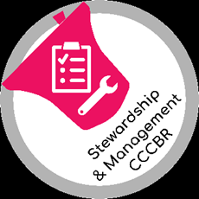
Date of inspection |  |  | Church  Map Ref. |  |  | Dedication
County
Diocese
TOWER | Location / plan (attach copy) |  |  | Material (e.g. stone, brick, flint…)
 | No. of buttresses |  |  | Level at top of buttresses
 | External access, lighting, signage, security
 | Internal access – stairs, ladders, handrails, lighting
 | Ground floor - flooring, walls, ceilings, windows, power supplies
 | Roof form and material
 | Internal chimney
 | Battlements
 | Lightning conductor |  |  | Cracks in stonework
 | Louvres fitted |  |  | Wire / plastic mesh netting
 | Flag pole
 | Weather vane
 | Sound control
 | Guttering/ drain pipes, gargoyles / ingress of water
 | Openings to nave ceiling / roof
 | Interior dimensions, frame level E-W N-S
 | Strong direction of tower
 | Clock | Maker |  | Date | Faces
 | Clock case
 | Winding mechanism
 | Hammers, clearance from bells when held off
 | Chimes
 | Intermediate rooms - Flooring, walls, ceilings, windows

RINGING ROOM | No. of bells | Ring of | How rung
 | Level of ringing room
 | Ellacombe chiming hammers |  | Clock hammers
 | Ropes, including spares
 | Peal boards
 | Rope guides, rope path – flapper boards, drawing, pulleys, bosses, guides, chutes at all levels
 | Simulator
 | Ringers’ boxes

FRAME AND BELL INSTALLATIION | Material | Plan (Attach a separate sheet, if required)  N
 | Type (Pickford classification)
 | Age
 | Decay, insect attack
 | Tie rods
 | Type of bearings
 | Level of bearings above / below window
 | How mounted
 | Frame beams
 | Floor

(repeat the following sheets according to number of bells in tower)
Bell number
Diameter at mouth
Soundbow thickness |  | Wear at Ellacombe, clock chiming points
Weight
Crown staple, cast in or independent
Turned
Tuning marks, machine or chip tuned
Musical note
Harmonics
Tone
Integrity, cracks
Canons
Argent
Lip to shoulder dimension
Shoulders
Casting quality
Founder
Date
Listing
Moulding wires
Fittings | Headstock – material
 | Headstock - condition
 | Straps / bell bolts
 | Bell loose on stock
 | Gudgeons e.g. hoop/plate (wooden stocks) riveted/bolted (metal stocks)
Wheel, all component parts.
Is wheel true
 | Stay, dimensions
 | Spare stay
 | Slider and dingler
 | Clapper type
 | Clapper bushes, clapper roll
 | Ground pulley - single or double roller; condition of bearings and sheaves

Inscription | bell
 | bell
 | bell
 | bell

Additional comments , photos, sketches
(with captions, scales etc)

Inspection by:  Name:  Position: | Name:  Position:

CCCBR Stewardship & Management Workgroup
V1 January 2021

