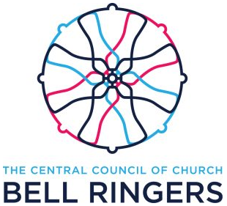
Registered Small Society Application

__________________________________________________ would like to apply to be a Registered Small Society of the Central Council of Church Bell Ringers and we confirm that:
- Our society’s purpose is to promote the ringing of bells by a group or association of bell ringers
- We have a written constitution and duly appointed officers
- We have safeguarding arrangements (dealing with the safeguarding of children and vulnerable adults) that reflect local best practice
- We will supply with this application details of our constitution, membership, safeguarding arrangements and sample ringing programme.
- We have 75 or fewer members Number of members: ____________
- Our activities will not unreasonably frustrate any other Affiliated Society or Registered Small Society.
- We will abide by the Council's Rules and Decisions
We (being duly appointed officers) confirm our society agreement to the above conditions:
(Print names clearly)

Name: Position:

Signature: Phone:

Address: Email:

Name: Position:

Signature: Phone:

Address: Email:

Date: Email address for society:

Send the completed form to the Small Society mailbox: smallsocieties@cccbr.org.uk

