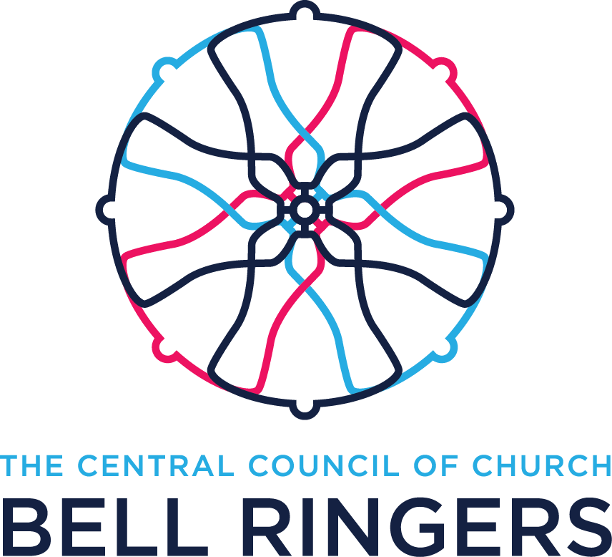
Appendix A
The sample given below is intended as a bell ringers’ input to any Parish document.
The content may vary according to local circumstance.
Sample Role Description for Bell Ringing Leader

Name of church, Name of parish
Role Description for Bell Ringing Leader
The role description outlined below is divide into two sections, the first covering the practical requirements of the role and the second the associated safeguarding responsibilities.

Practical Requirements
The post holder, known as Tower Captain or Tower leader, should be a competent bell ringer and will fulfil the following general requirements:
- Be first point of contact with incumbent, PCC and parish office
- Take responsibility for arrangements for the bells to be rung for services and for other occasions as required
- Maintain a team of ringers, including arrangements for training of new recruits and advancement of skills
- Ensure that activities in the tower are carried out safely including any day to day maintenance
- Assist any persons appointed by the PCC to carry out risk assessments pertaining to the bell ringing sections of the church including tower and bell installation.
Parts of the above duties may be delegated to an agreed role including, where appropriate, tower secretary - correspondence, steeple keeper – maintenance, trainer or assistant – training of recruits.
The tower leader will ensure that activities in the tower are carried out in accordance with the Parish Safeguarding Policy as set out below.

Parish Safeguarding Principles
We take the safety of everyone within the church very seriously and expect everyone to work in accordance with the Diocesan Safeguarding Policy. A copy of the Safeguarding Policy should accompany this Role Description.
This Role Description is binding in honour only, and is does not create a legally binding contract between us. It may be cancelled at any time at the discretion of either party. No employment relationship is to be created either now or in the future.
Volunteers working with children and/or adults at risk must have a commitment to:
- Treat individuals with respect;
- Recognise and respect their abilities and potential for development;
- Promote their rights to make their own decisions and choices, unless it is unsafe;
- Ensure their welfare and safety;
- The promotion of social justice, social responsibility and respect for others; and
- Confidentiality, never passing on personal information (except to the person to whom you are responsible) unless there are safeguarding issues of concern.
Safeguarding issues of concern (e.g. an allegation of abuse) must always be reported to the Parish Safeguarding Officer or the Diocesan Safeguarding Adviser.

Responsibilities of this Role
- To provide a safe environment for the teaching and management of bell ringing for children.
- To ensure that health and safety requirements for the activity are strictly observed due to the physical nature of bell ringing and in accordance with Safety Statement to the PCC.
- To supervise any adults who are assisting with the training and activity of children in the tower
- To ensure that safeguarding policies of the Parish are adhered to and that guidelines issued by the Central Council of Church Bell Ringers via the Dioceses are followed.
- To create a welcoming and sympathetic environment for the activities of children.
- To liaise with parents or guardians of children regarding expectations of the activity.
- To ensure that there are no medical or physical limitations of any child which could represent a risk.
- To act as the first contact for any concerns whether voiced by children or parent/guardian.
- To work in accordance with the Diocesan Safeguarding Policy and to report any areas of concern (see ‘what to do if…’ on website).

Accountability
When carrying out the above responsibilities you will be accountable to:
- The incumbent - Name
- Parish safeguarding team
- … and through them to the PCC

Responsibilities of the Church
As a valued volunteer, you can expect the church:
- To provide a supportive, inclusive and positive environment that helps you to enjoy this role.
- To treat you with respect and courtesy.
- To provide you with appropriate Safeguarding training.

Person Specification
- To have practical experience in the teaching and management of bell ringing.
- To have experience of working with children and young people.
- To understand the needs of children in a predominantly adult environment.
- To be willing to develop skills and to engage with training as appropriate.
- To keep up to date with matters relating to this role.

DBS Check
As a volunteer working with children this role requires an Enhanced DBS check with barred list information. This DBS check needs to be renewed every five years unless obviated by subscribing to the on-line update service.

Signature

Name and position held

Date

Based on Diocesan example

