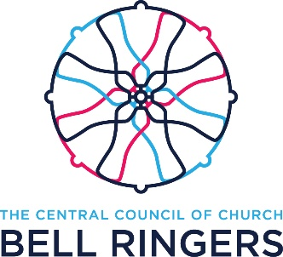
Central Council of Church Bell Ringers
Public Relations Officer

The role of Public Relations Officer (PRO) is a key strategic role with the Central Council of Church Bell Ringers (CCCBR). It presents the outward face of bellringing by co-ordinating and liaising with internal and external stakeholders to promote bellringing to church and communities in a positive way.
A candidate for the role of PRO can be offered to the CCCBR Executive for approval.
Responsibilities:
The PRO shall be responsible for co-ordinating publicity activities including providing press liaison, a point of contact for public enquiries and a source of material for use by ringers for the promotion of bellringing.

The PRO is not a member of the CCCBR Executive but is invited, in a non-voting capacity, to attend monthly Executive meetings to understand the strategic direction of the CCCBR and add any insights that may affect the perception of bellringing in the media.

The PRO is required to actively participate in the activities of the Ringing 2030 Marketing Workgroup and across other activities where support is required for public interaction.

The PRO is supported by an Executive Sponsor who can provide guidance and support as required.

The Role:
- To arrange press releases, interviews and photo opportunities where necessary via TV, radio and local, national and international press
- To answer enquiries from ringers, public, press and clergy whilst liaising with the Executive as required
- Attend the Executive monthly meetings
- To arrange publicity activities relating to major events and promotional opportunities in conjunction with the Ringing 2030 Marketing Workgroup
- To attend the CCCBR AGM and report to members
- Keep the Executive FULLY informed of actions and seek advice BEFORE making any press releases or acting on behalf of the CCCBR particularly in matters of significance

