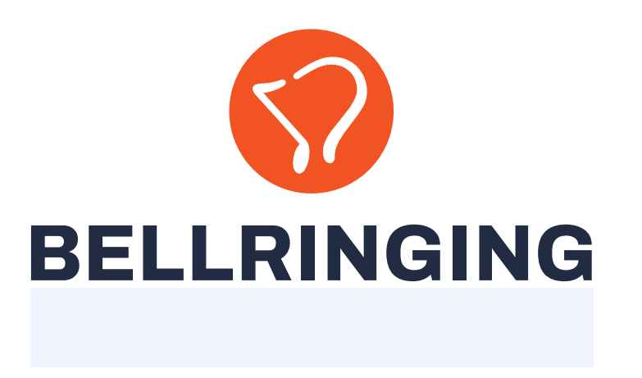

**Young Ringers for Ringing 2030 - Ringing in Schools**

**What is Young Ringers for Ringing 2030?**

There are three key components to the Young Ringers for Ringing 2030 Workstream. Hopefully you will have seen my article on the Young Ringers Hub, which was published in the Ringing World on 25th October, as well as the CCCBR website and across social media platforms. This will create new content and reference existing for under 18s (including youth groups), 18-30s, university ringing and resources for ringing leaders.

The Ringing in Schools project is the second key component of this workstream and there is another project around how youth ringing is led and organised, that needs more work to define its objectives, which will be kicked off early in 2025.

**What is the Ringing in Schools project?**

The Ringing in Schools project aims to raise awareness of ringing in schools by aligning bespoke lesson plans to the national curriculum and supporting the school’s coverage of the teaching of British values. The aim is that teachers will be able to use the lessons instead of or supplementary to their planned lessons and be able to reference where the lesson fits within it.

Raising awareness amongst children is vital as the traditional avenues for recruitment through the church are now less effective. Greater awareness in schools could potentially deliver a sustainable pipeline of young ringers as well as downstream when a young person goes to university or moves somewhere new and they hear the bells ringing.

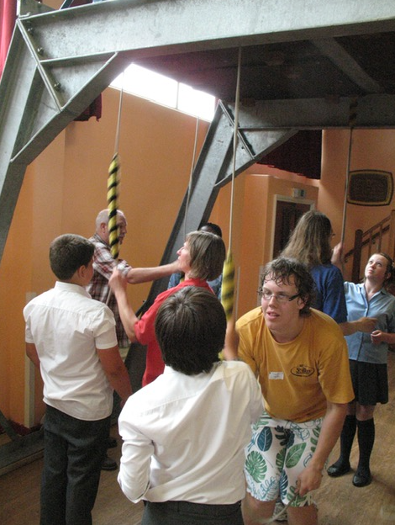

**What have we done so far?**

Some excellent work has been done by Jason Hughes to create lesson plans across the primary curriculum, which have been trialled in a number of schools and the learning incorporated into the next steps. There are 14 primary lesson plans across maths, literacy, music, art, design & technology, science, history, PHSE and computing. There is also an introductory lesson, tower visit and plenary session. So far, 4 secondary plans have been developed in drama, English, history and religious studies, plus an introductory lesson, tower visit and plenary session.

One of the key learnings from the trials was the large amount of effort needed to arrange and run the practical sessions, which will be factored into next steps.

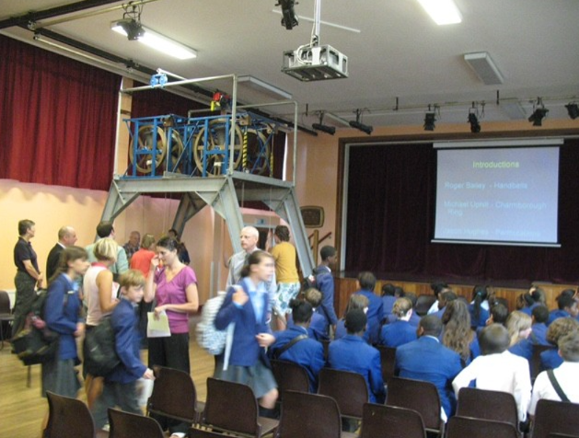

**What are we doing next?**

Now that we have a road tested product, we are turning our attention to how we roll the lesson plans out and make sure that the product is sustainable. This is a huge task and needs clear governance around the development, delivery and business as usual stages.

The key project outcomes we are aiming to achieve are:

* Lesson plans across the primary and secondary curriculum are technically complete – 14 Primary and 14 Secondary
* Lesson plans are branded using the new Bellringing branding, marketed, sustainable, quality assured and available for use across various platforms
* PowerPoint resources in place to support teaching
* Resources are identified that are needed to support the project once in business as usual e.g. volunteers for events, paid admin support, cost, quality assurance, updating materials, bookings for events etc
* Sustainable operating model and steering board is in place
* Lesson plans include clear “what next” information to signpost young people to ART, DofE guidance, Young Ringers Hub, Young Change Ringers Association, Ringing World National Youth Competition etc.
* Incremental roll out plan is in place, leveraging teachers within the ringing community
* Lesson plans are aligned with Mobile Belfies and other ringing organisations
* Links created to other suppliers of schools resources
* Success criteria defined and measured

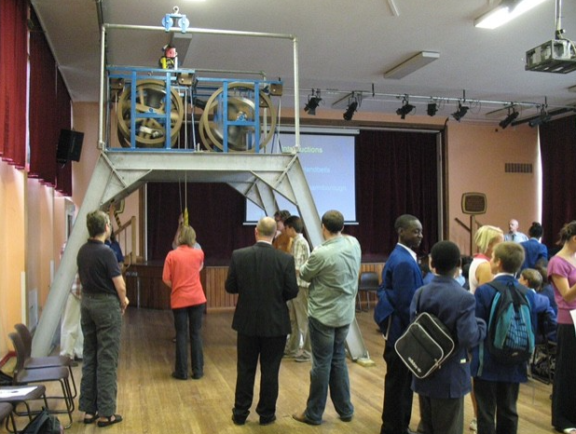

**How are we doing it?**

A team of volunteers is needed to lead the key activities through the development, delivery and business as usual stages, led by a Project Manager. Each activity will have a clear scope and timeframe and will be assigned to volunteers based on experience and availability.

The support we need for the key activities is as follows:

* Project manager
* Project planning and monitoring
* Quality control / peer review
* Teachers and others with links to schools, Academy Trusts etc to help devise an incremental roll out plan
* Experience of creating operating models / trusts

As workstream lead, I am acting as project sponsor, reporting to Ian Roulstone, CCCBR Executive Sponsor. It’s my job to make sure we deliver the benefits we set out to achieve. I used to do this with railways. It’s just the same, but I don’t get paid any more!

**Future plans**

Once the project is up and running, consideration can be given to how the lesson plans could be adapted for international use.

**Contact us**

Thanks to those who have already been in touch offering your valuable time, this is much appreciated. I will get back to you soon if I haven’t already!

If you are interested in getting involved, please contact me on [andrea.haynes@cccbr.org.uk](mailto:andrea.haynes@cccbr.org.uk)

Regular updates will be posted on the Central Council website via the following link:

[Young Ringers for Ringing 2030 – CCCBR](https://cccbr.org.uk/about/workgroups/schools-and-youth-groups/)